**Task 3 for submission**

*Task 3 addresses* ***Unit Objective 2 – Apply accounting principles and processes relating to managing resources for a trading GST business***

**Part A**

Using the information provided for Davies Enterprises, apply accounting principles and processes to:

* 1. calculate depreciation using the diminishing balance method for both vehicles up to and including 30 June 2019.

Use the Excel workbook *PPT3-U3-T1-Task 3.xls* – *Part A* *Dep Calc* sheet.

* 1. record transactions, including closing entries, from 1 July 2017 to 30 June 2019 in the accounts provided in the general ledger (extract) – Depreciation on delivery vehicles, Delivery vehicle expenses, Delivery Vehicles, Accumulated depreciation on delivery vehicles.

Use the Excel workbook *PPT3-U3-T1-Task 3.xls* – *Part A General ledger* sheet.

* 1. report account balances relating to the non-current assets in the two Statements of Financial Position (extract) as at 30 June 2018 and 30 June 2019.

Use the Excel workbook *PPT3-U3-T1-Task 3.xls* – *Part A FP* sheet.

All delivery vehicles are depreciated at 35% per annum.

The following transactions occurred relating to two delivery vehicles:

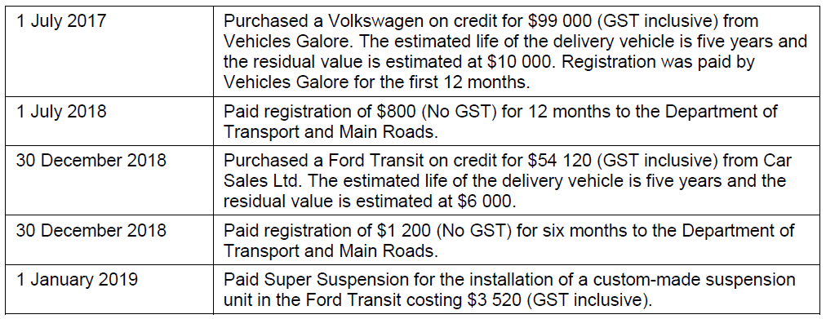

**Part B**

Using the information provided for Tranter Traders, apply accounting principles and processes to:

1. calculate depreciation.

Use the Excel workbook *PPT3-U3-T1-Task 3.xls* – *Part B* *Dep Calc* sheet.

1. record the disposal of the shelving in the Disposal of Furniture and Fittings a/c in the general ledger (extract).

Use the Excel workbook *PPT3-U3-T1-Task 3.xls* – *Part B* *General ledger* sheet.

1. report amounts for the relevant accounts in the Statement of Profit or Loss (extract) for the year ended 30 June 2019.

Use the Excel workbook *PPT3-U3-T1-Task 3.xls* – *Part B* *PL* sheet.

On 31 March 2019, the owner of Tranter Traders sold shelving purchased on 1 July 2016 to Commercial Shop Fittings Ltd for $13 497 cash (including GST).

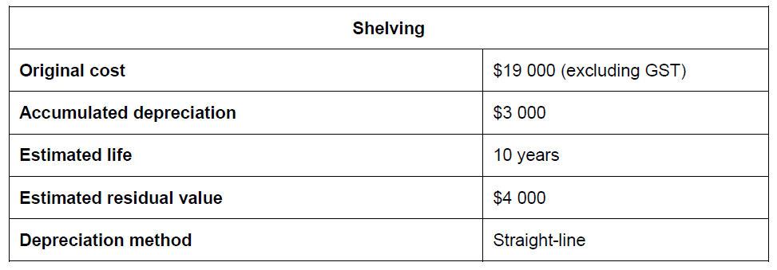

**The questions in this task meet the specifications for the Apply questions in the IA1 exam.**

**The Instument Specific Marking Guides (ISMG) below will be used to mark the Apply questions in IA1.**

